JavaScript Report
10/13/2026  Web Programming | Adam Carling  Dr. Barker

Overview

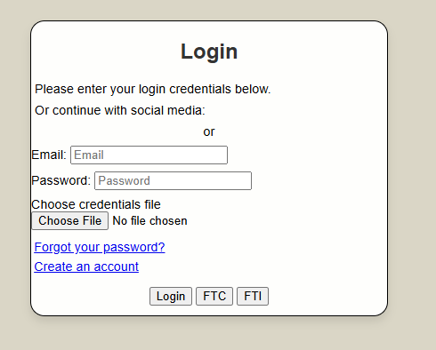
I created the login page. It has some JavaScript that validates the username and password. Looking back, I realize that most of this will be unusable because checking usernames and passwords must be a server side function. But the code is nice.
 | Code used
 | 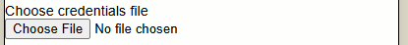  There is an issue when trying to load local txt files from a web page, so currently the temp_database must be uploaded for the username and password to be validated against it.  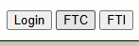  Kinda Silly. I added buttons to the bottom that stand for “Forma Tabularum Rectus” and “Forma Tabularum Mendosum” They auto populate the email and password field with valid and invalid data, respectively. | The whole JavaScript File boils down to these two nested if else statements. If the email address exists in the database and the password matches the selected email, alert the user that they logged in successfully. If at any point either of these checks fail, run the login error code.  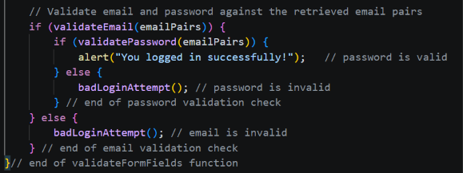  I chose to keep the login error vague to prevent username guessing.

